Fitness 4
Name | Type | Description | Picture | Repetitions | Time
Run | Cardio-respiratory | Run…… |  | 1-3 laps  2-4 laps  3-3 laps AND 1 sprint lap
Walk down Plank and slaps | Arms | Walk your hands out one "step" at a time until you are in a full high plank position, lift one hand off of the ground at a time to “slap” the opposite shoulder. Walk yourself back up to the starting position and repeat. | 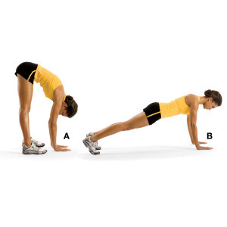 | 1-8  2-12  3-16
Arm circles | Arms | Stand up. Put your arms out. Do a cycle of big circles clock wise and counter clock wise. Then small fast circles clock wise and counter clock wise. You will be doing 4 arm circle cycles. | 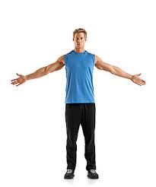 |  | 1-25 seconds for each cycle (4 cycles)  2-40 seconds for each cycle (4 cycles)  3-50 seconds for each cycle (4 cycles)
Tripod | Legs | Sit with legs bent in front of you and arms behind you (like you’re going to do triceps), then put butt up and reach with one arm, come back down (like a sitting down squat…), and then switch with the other arm. Open up shoulders and hips | 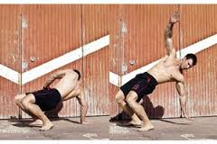 | 1-6  2-9  3-12
Hamstring Stretch | Legs | Sit down with legs out. Bend one leg and have the foot touch the other leg. Reach as far as you can. Switch after time. | 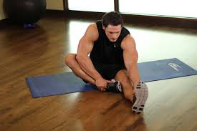 |  | Every group-30 seconds each leg
Suitcase | Core | Lay flat on your back with legs stretched out and arms stretched out above your head flat on the ground. Put legs up and reach up to toes with hands. Then lay back down. | (look at Ms. M for demonstration) | 1-8 touch ground with legs  2-10 don’t touch the ground with legs  3-14 don’t touch the ground with legs

DO CORRECT FORM! Do your best and set a goal to reach. PICK THE LEVEL THAT FITS YOU. Let your fitness group push each other. YOU CAN ALWAYS DO MORE!

