Name | Type | Description | Picture/Barcode | Repetitions | Time
Run in place | Cardio | Find a spot. Run in place. Higher the knees, higher the difficulty level. KEEP YOUR BACK STRAIGHT. | 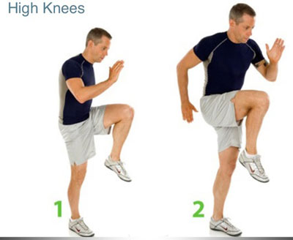 |  | 1-30 seconds run  2-40 seconds high knees  3-60 seconds high knees
Lunges | Legs | Stand with a straight back. Take a large step. Bend (with a straight back) to where the knee is above the ankle. | 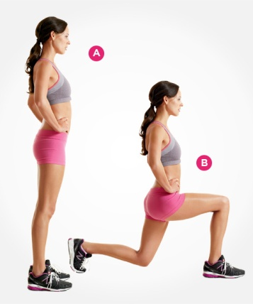 | 1-10 each side  2-8 each side with the back foot step  2-13 each side with back foot on step
Body squats | Legs | Stand with feet shoulder width apart. Squat like you were about to sit in a chair. Legs to butt is 90 degrees. Knees are above the ankles. Then come back up. | 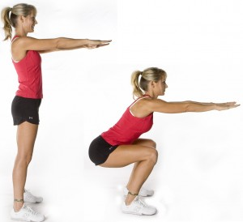 | 1-10  2-14  3-18
Push ups | Arms | Bent legs=put knees on floor. Legs, butt, and back lined up with each other. Hands apart. Bend elbows down.  Straight legs=same, but with straight legs | 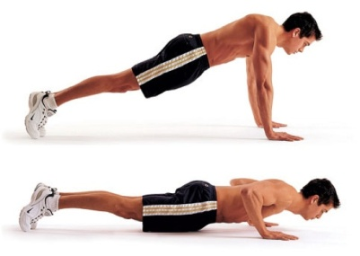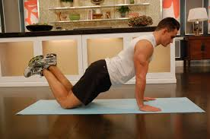 | 1-8 bent knee, 2 straight legs  2-9 straight legs  3-15 straight legs
Plank | Core and arms | Rest on forearms and toes. Legs, butt, and back are all lined up with each other. Shoulders above elbows. | 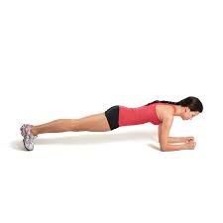 |  | 1-20 seconds  2-35 seconds  3-50 seconds
Teaser | Core | Lie on your back with knees bent to 90-degree angles and feet lifted. Tighten abs as you inhale, and lift arms up and back over head.  Exhale and swing arms forward, straightening legs so your body forms a V. If needed, put hands on the floor for support.  Roll down slowly, bending knees and bringing arms overhead | 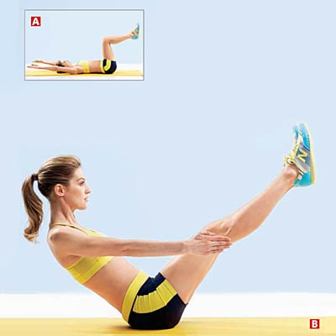 | 1-5  2-8  3-14

Do all and do proper form. Let your fitness group push each other. PICK THE LEVEL THAT FITS YOU. YOU CAN ALWAYS DO MORE!

